Map of Bangladesh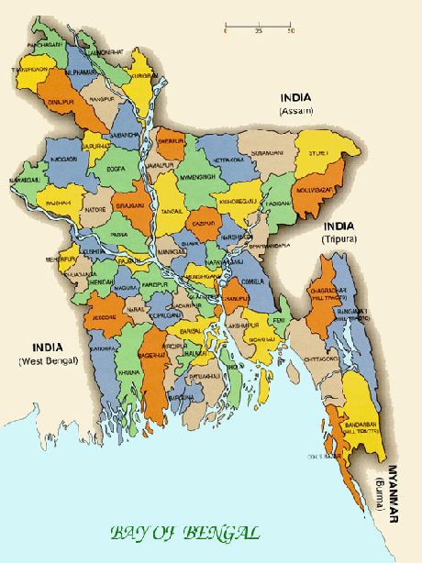

From the map, we can see that the country’s boundary is bounded by India from north, west and east and in east Myanmar also lies on the boundary. On south, there is Bay of Bengal.

**Next**